Student ID: 700743212

Name: Sreenidhi Gundlapally

NN & DL - Assignment 5

**Video Link:**

GitHub Link:

**Importing the drive path**

**Importing set of libraries**

**Loading the dataset and selecting only necessary columns text and sentiment**

**Keeping only necessary columns**

**Removing the Re Tweets**

**Max words 2000 to tokenize the sentence**

**Padding the matrix**

**Using function to compile the model**

**Applying the label encode matrix**

**Batch size is set to 32 and executing the model is done**

**Metrics of the model**

**1. Saving the model which we used to predict**

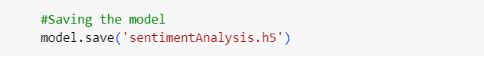

**Importing the package for saved model**

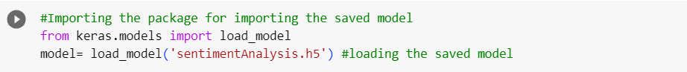

**Predicting the test data**

**2. Apply GridSearchCV on the source code provided in the class**

